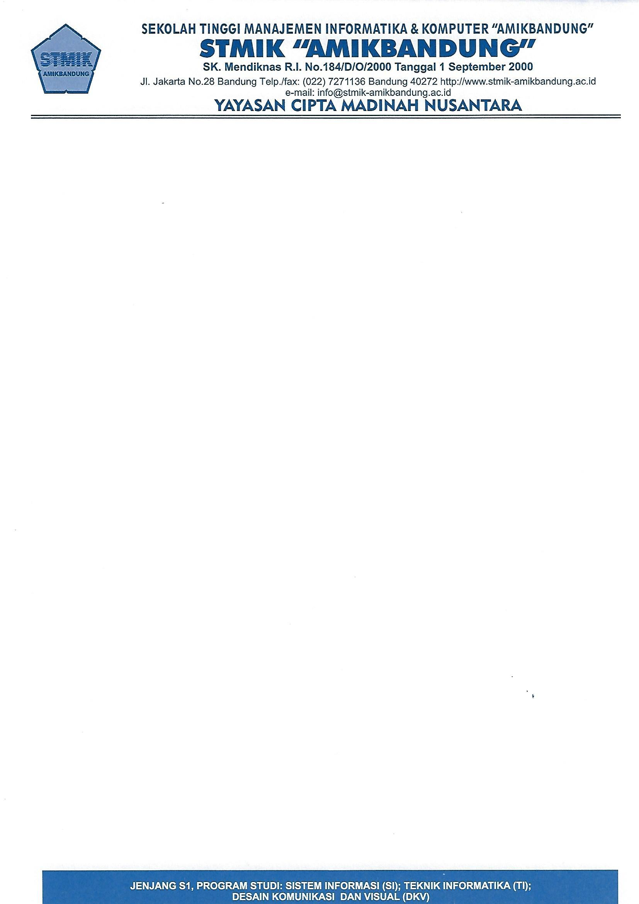

FORMULIR AKTIVITAS MINGGUAN LOGBOOK MAHASISWA

Nama : sani swandika___________________________________________

NPM : 1942489_______________________________________________

**Pembimbing Industri**

Nama : Akbar Dhany Widiyanto___________________________________

Jabatan : Web Developer________________________________________________

|  |  |  |  |
| --- | --- | --- | --- |
| **No.** | **Tanggal\*** | **Materi** | **Hasil\*\*** |
| 1. | (25-11-2022) | 1. migrasi table data baru | **COMPLETE** |
| 2. | (26-11-2022) | 1. perubahan route dan penambahan route impor setiap menu data | **COMPLETE** |
| 3. | (28-11-2022) | 1. perubahan sidebar menu susuai abjad | **COMPLETE** |
| 4. | (30-11-2022) | 1. perubahan menu manage roles user | **COMPLETE** |
| 5. | (31-11-2022) | 1.membuat modals di menu register | **COMPLETE** |

*) Dilaporkan dan dievaluasi setiap minggu

**) Hasil diisi dengan skoring evaluasi kegiatan mahasiswa berupa penilaian kualitatif (baik, cukup,

Bandung, 23-11-2022

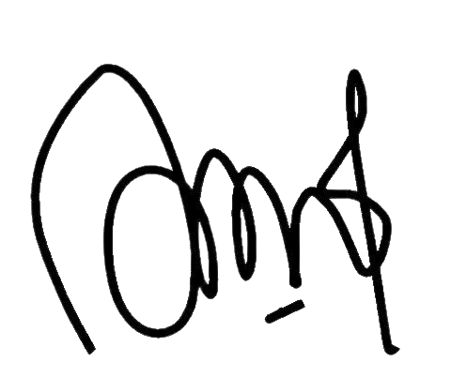

**(**Akbar Dhany Widiyanto

kurang yang disertai masukan / komentar) atau kuantitatif (angka).





FORMULIR AKTIVITAS MINGGUAN LOGBOOK MAHASISWA

Nama : sani swandika___________________________________________

NPM : 1942489_______________________________________________

**Pembimbing Industri**

Nama : Akbar Dhany Widiyanto___________________________________

Jabatan : Web Developer________________________________________________

|  |  |  |  |
| --- | --- | --- | --- |
| **No.** | **Tanggal\*** | **Materi** | **Hasil\*\*** |
| 1. | (1-11-2022) | 1. membuat fitur baru "menu pengaduan" | **COMPLETE** |
| 2. | (2-10-2022) | 1. Merubah tampilan menjadi modals atau pop di menmu role users | **COMPLETE** |
| 3. | (3-10-2022) | 1. merubah all menu sside sesuai dengan role user yang di piilih | **COMPLETE** |
| 4. | (4-11-2022) | 1.tambah akses kelurahan  2. solving menu kelurahan fitur pengadungan crud dan izin akses perkelurahan | **COMPLETE** |
| 5. | (5-11-2022) | 1. solved menu pengaduan sama permohonan  2.index blade menu pengaduan dan menu permohonan | **COMPLETE** |

*) Dilaporkan dan dievaluasi setiap minggu

**) Hasil diisi dengan skoring evaluasi kegiatan mahasiswa berupa penilaian kualitatif (baik, cukup,

kurang yang disertai masukan / komentar) atau kuantitatif (angka).



Bandung, 23-11-2022



**(**Akbar Dhany Widianto**)**



FORMULIR AKTIVITAS MINGGUAN LOGBOOK MAHASISWA

Nama : sani swandika___________________________________________

NPM : 1942489_______________________________________________

**Pembimbing Industri**

Nama : Akbar Dhany Widiyanto___________________________________

Jabatan : Web Developer________________________________________________

|  |  |  |  |
| --- | --- | --- | --- |
| **No.** | **Tanggal\*** | **Materi** | **Hasil\*\*** |
| 1. | (8-11-2022) | 1.Penyesuaian huruf dan solved menu roles | **COMPLETE** |
| 2. | (9-11-2022) | 1. Membuat fitur import dan export di halmaan dtks | **COMPLETE** |
| 3. | (10-11-2022) | 1. pengaduan delete  2. solved menu pengaduan | **COMPLETE** |
| 4. | (11-11-2022) | 1. membuat fungsi search master data | **COMPLETE** |
| 5. | (12-11-2022) | 1. solving menu dasboard | **COMPLETE** |

*) Dilaporkan dan dievaluasi setiap minggu

**) Hasil diisi dengan skoring evaluasi kegiatan mahasiswa berupa penilaian kualitatif (baik, cukup,

Bandung, 23-11-2022



**(** Akbar Dhany Widianto **)**

kurang yang disertai masukan / komentar) atau kuantitatif (angka).





FORMULIR AKTIVITAS MINGGUAN LOGBOOK MAHASISWA

Nama : sani swandika___________________________________________

NPM : 1942489_______________________________________________

**Pembimbing Industri**

Nama : Akbar Dhany Widiyanto___________________________________

Jabatan : Web Developer________________________________________________

|  |  |  |  |
| --- | --- | --- | --- |
| **No.** | **Tanggal\*** | **Materi** | **Hasil\*\*** |
| 1. | (15-11-2022) | 1. solving menu manager user production  2. solving huruf | **COMPLETE** |
| 2. | (16-11-2022) | 1. solving menu permohonan | **COMPLETE** |
| 3. | (17-11-2022) | 1. rapat di Dinas Sosial kota Bandung | **COMPLETE** |
| 4. | (18-11-2022) | 1. membuat Rest full Api  2. solving permohonan dan pengaduan | **COMPLETE** |
| 5. | (19-11-2022) | 1. solving upload file | **COMPLETE** |

*) Dilaporkan dan dievaluasi setiap minggu

**) Hasil diisi dengan skoring evaluasi kegiatan mahasiswa berupa penilaian kualitatif (baik, cukup,

kurang yang disertai masukan / komentar) atau kuantitatif (angka).

Bandung, 23-11-2022



**(** Dhany Akbar Widianto **)**





FORMULIR AKTIVITAS MINGGUAN LOGBOOK MAHASISWA

Nama : sani swandika___________________________________________

NPM : 1942489_______________________________________________

**Pembimbing Industri**

Nama : Akbar Dhany Widiyanto___________________________________

Jabatan : Web Developer________________________________________________

|  |  |  |  |
| --- | --- | --- | --- |
| **No.** | **Tanggal\*** | **Materi** | **Hasil\*\*** |
| 1. | (21-11-2022) | 1.deploying system | **COMPLETE** |
| 2. | (22-11-2022) | 1. authorization api | **COMPLETE** |
| 3. | (23-11-2022) | 1. solving deploy server | **COMPLETE** |
| 4. | (24-11-2022) |  | **COMPLETE** |
| 5. | (25-11-2022) |  | **COMPLETE** |

*) Dilaporkan dan dievaluasi setiap minggu

**) Hasil diisi dengan skoring evaluasi kegiatan mahasiswa berupa penilaian kualitatif (baik, cukup,

Bandung, 23-11-2022



**(** Akbar Dhany Widianto **)**

kurang yang disertai masukan / komentar) atau kuantitatif (angka).

